**TERM WORK – II**

**Company Database**

**Consider the Customer Order Product Database:**

Department (Dno:int,Dname:string, mgr_ssn:number, mgr_start_date:date)

Employee(Ssn:number ,Fname:string, Mname:string, Lname:string,

Bdate:date, Address:string, Sex:character, Salary:decimal, Dno:int)

Project (Pnumber:int, Pname:string, Plocation:string, Dnum:int)

works_on(Ssn;number, Pno:int, Hours:number)

1. Draw ER and Schema Diagram
2. Create above tables by properly specifying primary and foreign keys.
3. Insert at least 5 values to all tables.
4. Select employees working for department 1 and 3
5. Retrieve bdate ,address of employee whose name is ‘Aashish A Kumar’
6. Retrieve the name, address of employees who are working for the “Development” department.
7. For every project located in Bangalore list project name, controlling department, Dnumber, department manager last name, address, bdate
8. Count number of employees department wise
9. Display name, project name and number of hour’s employee working on project.
10. Draw ER and Schema Diagram.

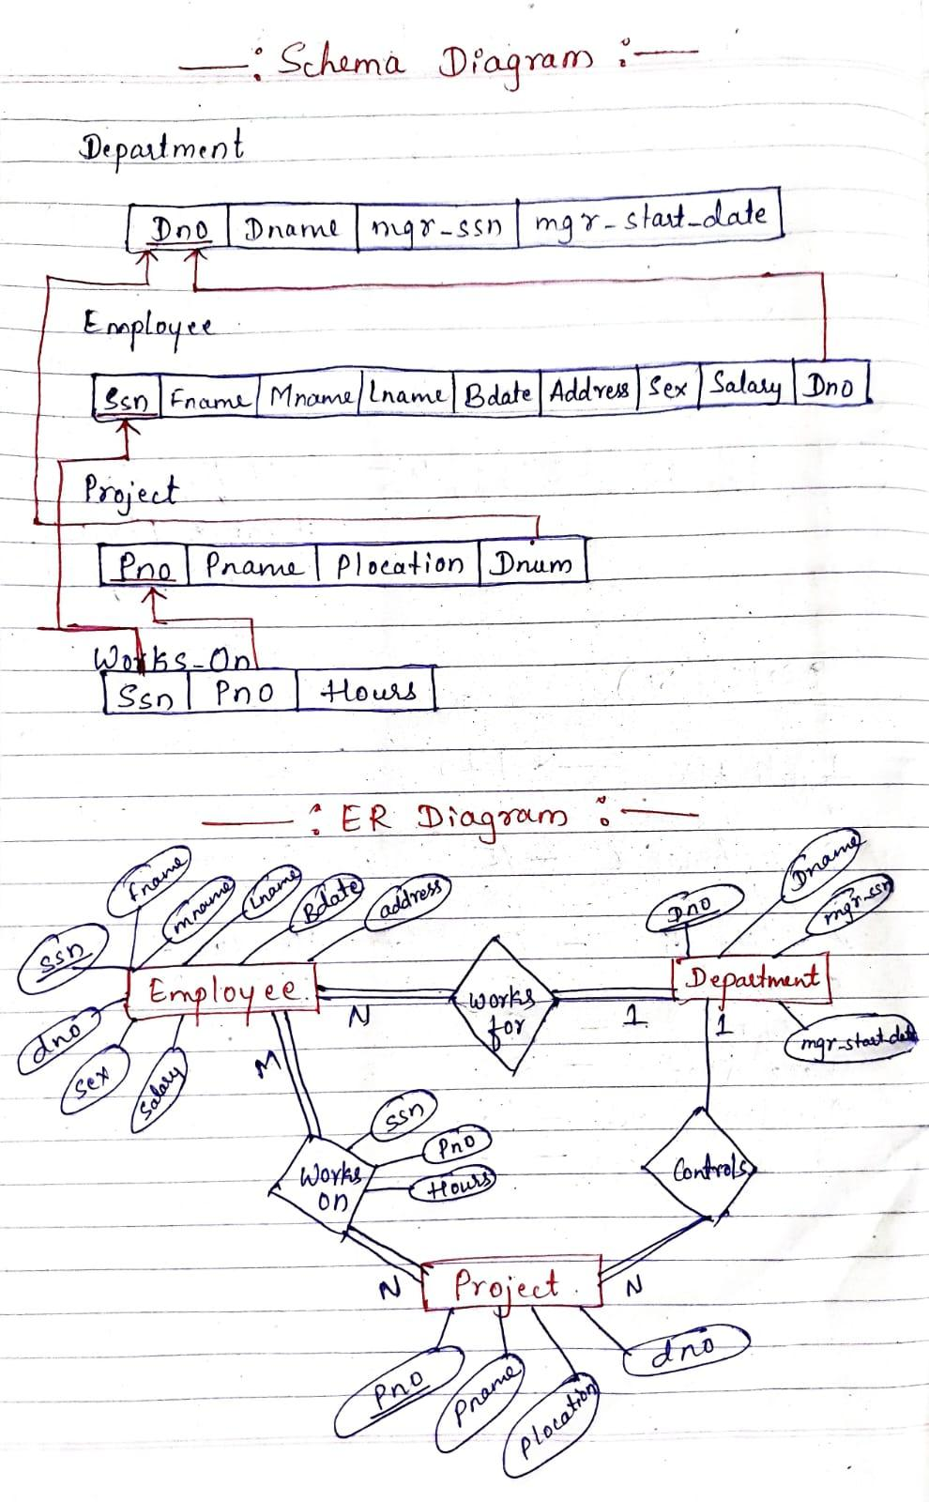

1. Create above tables by properly specifying primary and foreign keys.

create table deptbp

(dno int primary key,

dname varchar(20),

mgr_ssn number(4),

mgr_date date

);

Create table employeebp

(ssn number(5) primary key,

Fname varchar(20),

Mname varchar(20),

Lname varchar(20),

Bdate date,

Address varchar(20),

Sex varchar(2),

Salary number(10),

dno number(4)references deptbp(dno));

Create table projectbp

(pno number(4) primary key,

pname varchar(10),

Plocation varchar(10),

dno number(4) references deptbp(dno));

create table worksonbp

(ssn number(5) references employeebp(ssn),

pno number(4) references projectbp(pno),

hours number(4)

);

1. Insert at least 5 values to all tables.

Insert into deptbp values(1,'testing',100,'10-dec-15');

Insert into deptbp values(2,'development',101,'10-jan-10');

Insert into deptbp values(3,'hr',102,'10-oct-12');

Insert into deptbp values(4,'marketing',103,'10-dec-90');

Insert into deptbp values(5,'accounts',104,'23-dec-17');

Select * from deptbp;

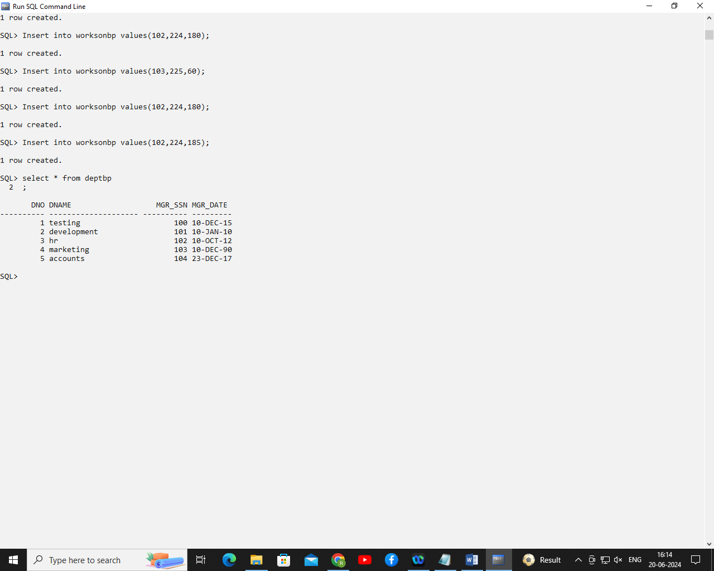

Insert into employeebp values(100,'aashish','a','kumar','1-jan-17','banglore','m',10000,1);

Insert into employeebp values(101,'ajay','b','patil','20-sep-21','manglore','m',20000,2);

Insert into employeebp values(102,'sudeep','d','kundagol','10-jan-22','hubli','m',25000,2);

Insert into employeebp values(103,'manju','s','patel','15-aug-19','dharwad','f',12000,3);

Insert into employeebp values(104,'arya','m','singh','19-sep-21','mumbai','m',25000,4);

Insert into employeebp values(105,'arya','m','singh','19-sep-21','mumbai','m',25000,5);

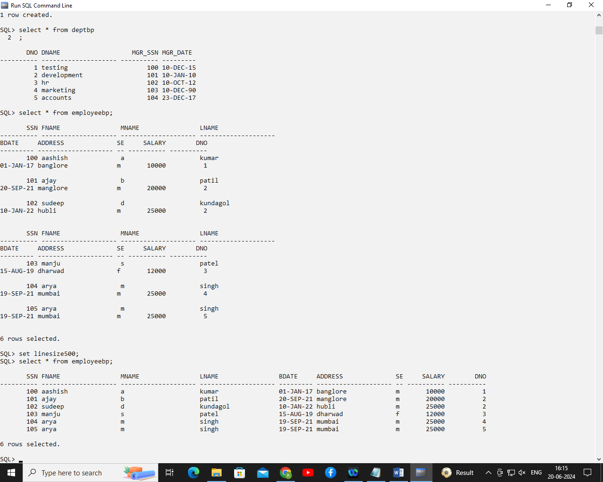

Insert into projectbp values(222,'robotics','hydrabad',1);

Insert into projectbp values(223,'Adharcard','bangalore',2);

Insert into projectbp values(224,'pancard','pune',3);

Insert into projectbp values(225,'ML','Mumbai',4);

Insert into projectbp values(226,'grenngrow','Mumbai',4);

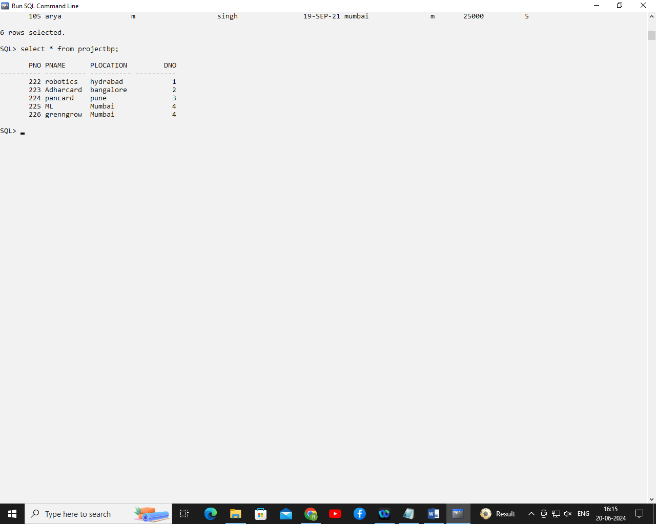

Insert into worksonbp values(100,222,120);

Insert into worksonbp values(101,223,160);

Insert into worksonbp values(102,224,180);

Insert into worksonbp values(103,225,60);

Insert into worksonbp values(102,224,180);

Insert into worksonbp values(102,224,185);

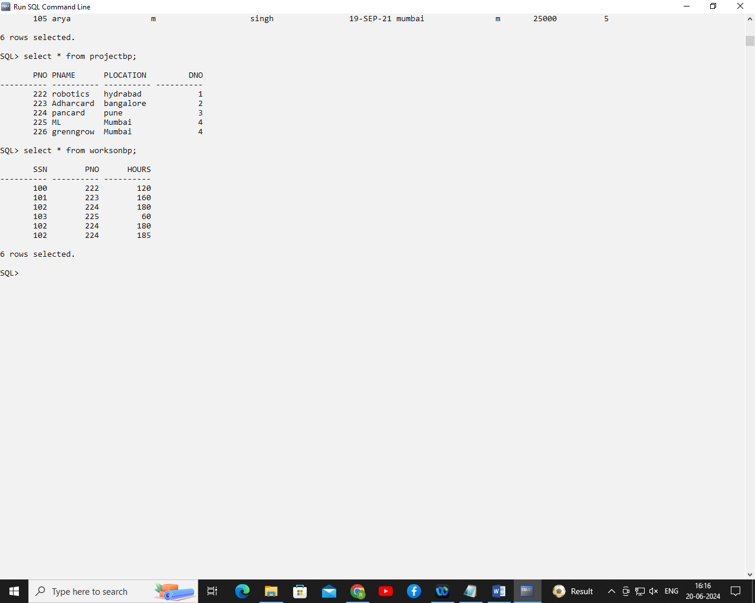

**MAIN QUERIES:**

1. Select employees working for department 1 and 3

select * from employeebp where dno=1 or dno=3;

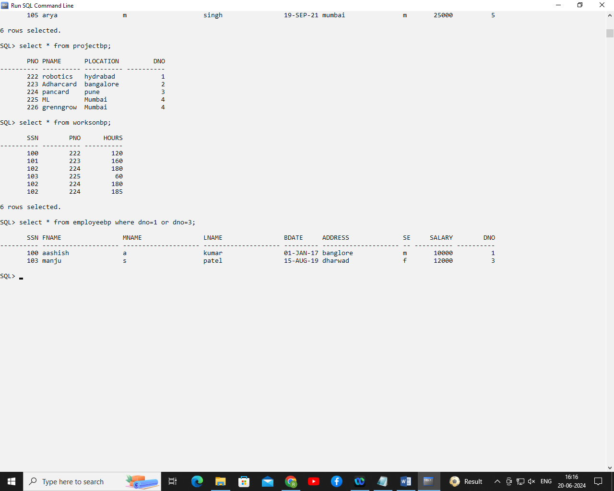

1. Retrieve bdate ,address of employee whose name is ‘Aashish A Kumar’.

select * from employeebp where fname='aashish' and mname='a' and lname='kumar';

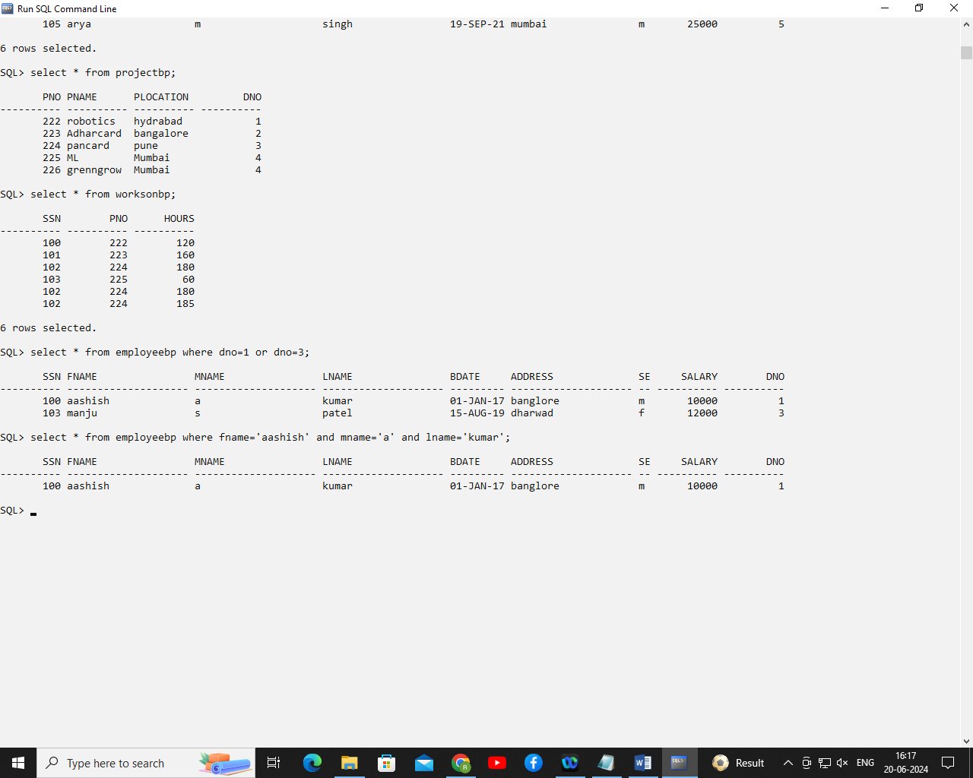

1. Retrieve name, address of employees who are working for “Development” department.

select fname,lname,address,dname from

employeebp e,deptbp d

where e.dno=d.dno and dname='development';

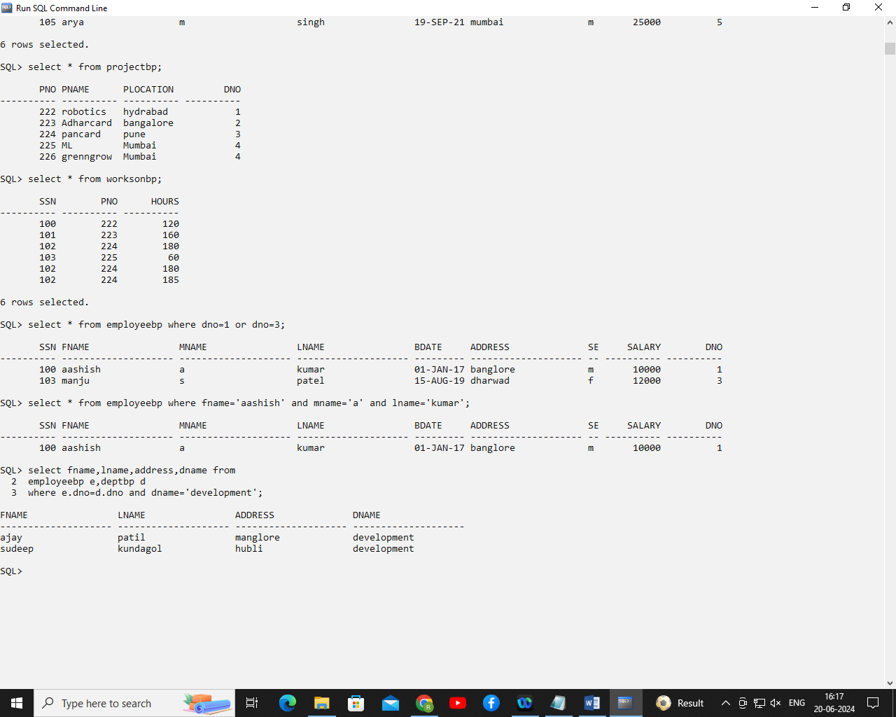

1. For every project located in Bangalore list project name, controlling department, Dnumber, department manager last name, address, bdate.

select pname,dname,lname,address,bdate ,plocation

from deptbp d,employeebp e,projectbp p

where

d.dno=e.dno and p.dno=d.dno

and plocation='bangalore';

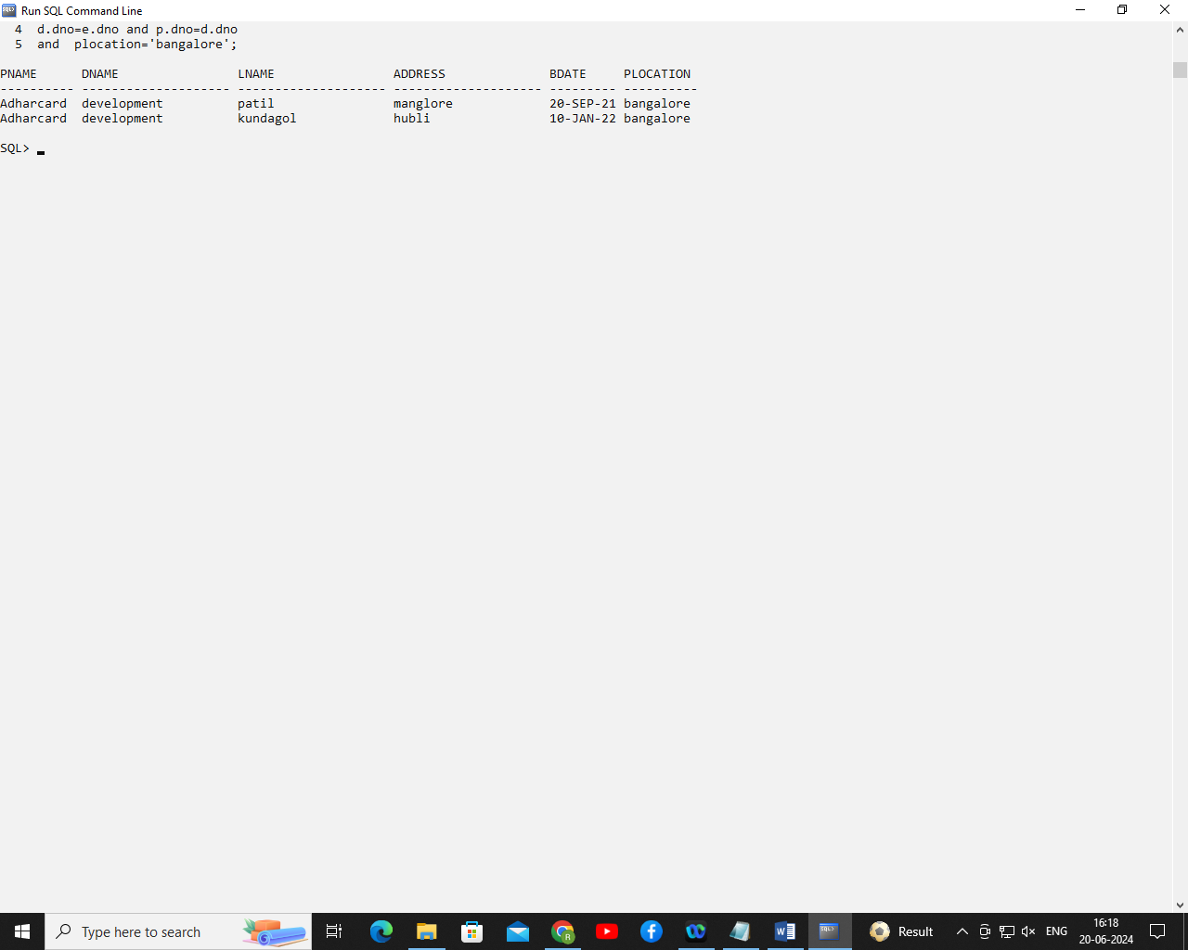

1. Count number of employees department wise.

select dname,count(*) from employeebp e,deptbp d

where e.dno=d.dno

group by dname;

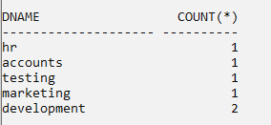

1. Display name, project name and number of hour’s employee working on project.

select fname,pname,hours

from employeebp e,projectbp p,worksonbp w

where e.ssn=w.ssn and p.pno=w.pno;

